- Create a new database called student_management.
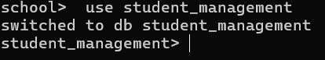
2.Create a collection called students in the student_management database.

- Insert at least five student records into the students collection. Each record should have the following fields:
    - student_id (integer)
    - name (string)
    - age (integer)
    - department (string)
    - courses (array of strings)
    - grade (string)
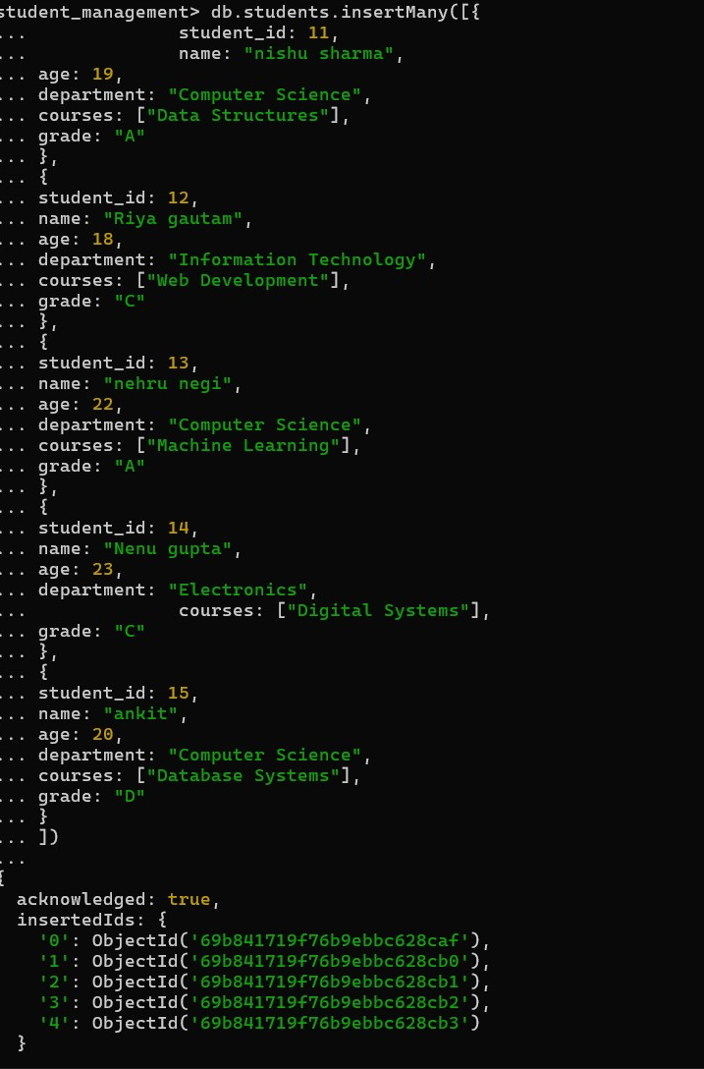

- Query the Collection:
Write queries to perform the following tasks:
  - Retrieve all students who are in the "Computer Science" department.
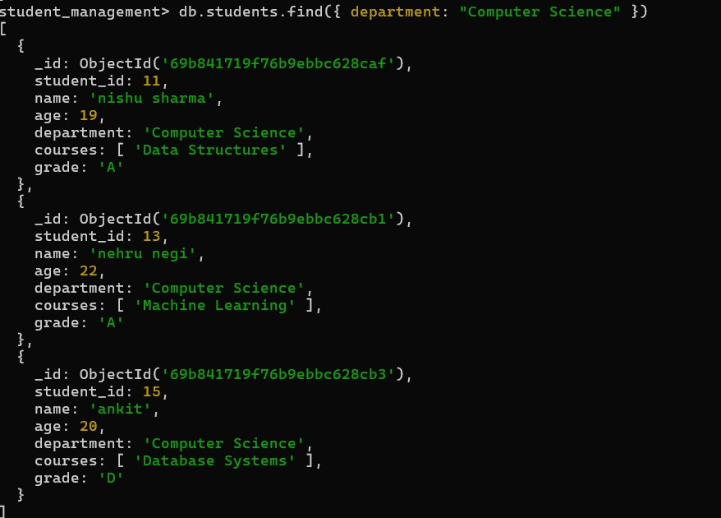
  - Retrieve students who have an age greater than 21.
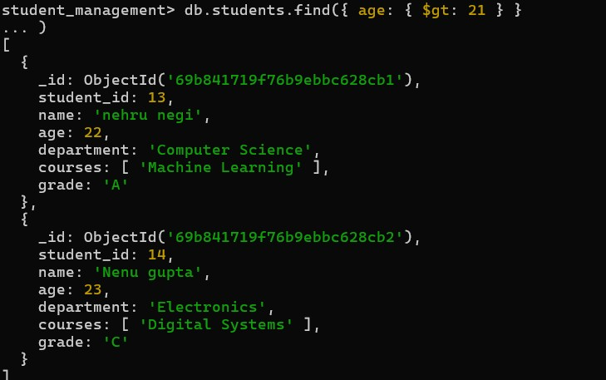
  - Retrieve students who are taking the "Database Systems" course.
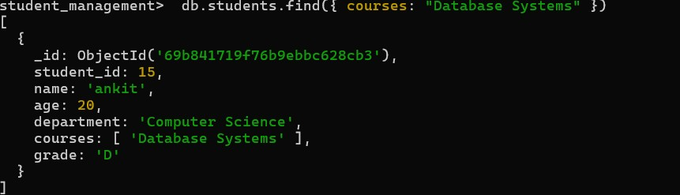
  - Retrieve students with a grade of "A".
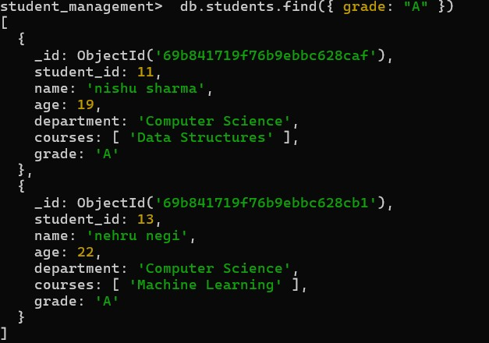
- Update Documents:
  - Update the age of a student with student_id 101 to 21.
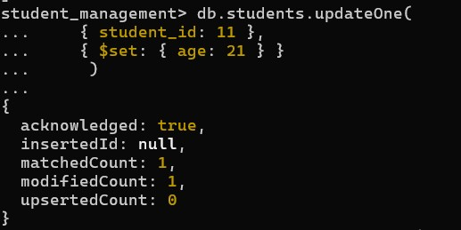
  - Add a new course, "Machine Learning", to the courses array for students in the "Computer Science" department.
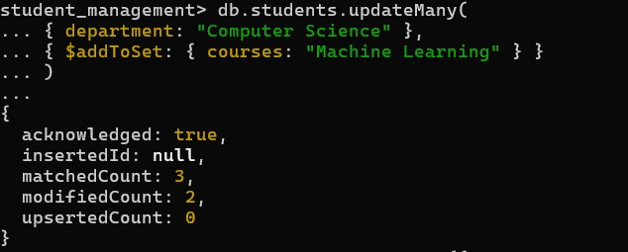
- Delete Documents:
- Delete a student record with student_id 105.
- Delete all students who have a grade lower than "C".

